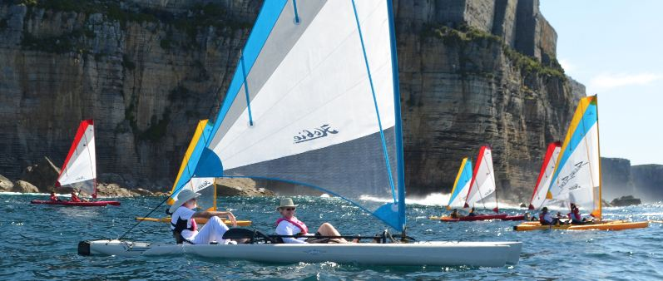

**Let’s Get Together and Have Fun!**

Hobie Cat Company

invites you to the

Hobie Island Club SoCal Rendezvous!

Please join us for clinics, camaraderie, sailing and fun!

This event will be held on

Saturday, October 13, 2012 at

Baby Beach, Dana Point Harbor, Dana Point, California

Please bring your fully equipped Hobie Island, life jackets, safety & sail gear, sun protection, dry-bag, water, towel, cell phone

**Our proposed itinerary for the day:**

**9:00 am: Arrive & check in (restrooms, shade & car parking near baby beach. See link for trailer parking)**

**10:00 -11:00 am: Boat House Clinic ~ Set-up and Sailing Basics ~ a fun review for all Hobie Island owners.**

**This clinic will be held, next to the beach at the Sailing & Events Center in the Boat House near the beach.**

**11:00 – 12 noon: Set-up your Island, mingle and meet other local Island owners and Hobie Cat staff.**

**12:00 - 1:00 pm: Meet** **on grass above baby beach for Hobie Island Club sponsored lunch and refreshments**

**1:00 - 4:00 pm:** **Let’s go sailing!** We’ll sail out of the Harbor, North depending on conditions, returning downwind

**4:00 – 5:00 pm:** **Back to Beach/Shore side** for refreshments and breakdown.

For vehicle parking

<https://maps.google.com/maps/ms?msid=209081478931209078160.0004c87f7baee5548c881&msa=0&ll=33.462774,-117.689023&spn=0.023343,0.045447>

Trailer Parking

<http://www.sailorschoice.com/DanaPointHarbor/dpboatingfacilities.htm>

Dana Point Area information

<http://www.danapointharbor.com/>

**R.S.V.P. by Oct. 5th for your Hobie Island Club SoCal Rendezvous Tee-Shirt - please let us know men or women’s sizes.**

**Please let us know you are coming! R.S.V.P. with Lorraine Garnier, Hobie Island Club Coordinator**

**Phone 760-758-9100 ext. 605 email**  [**lgarnier@hobiecat.com**](mailto:%20lgarnier@hobiecat.com)

